Team Bravo

Brittni Ray, Shanika Love, Aaron Crose II

CSD 310-J308

I had actually submitted our post-edit form or our ERD on Milestone 1, so I am going to post our pre-edit and post-edited ERD here:

PRE-EDIT

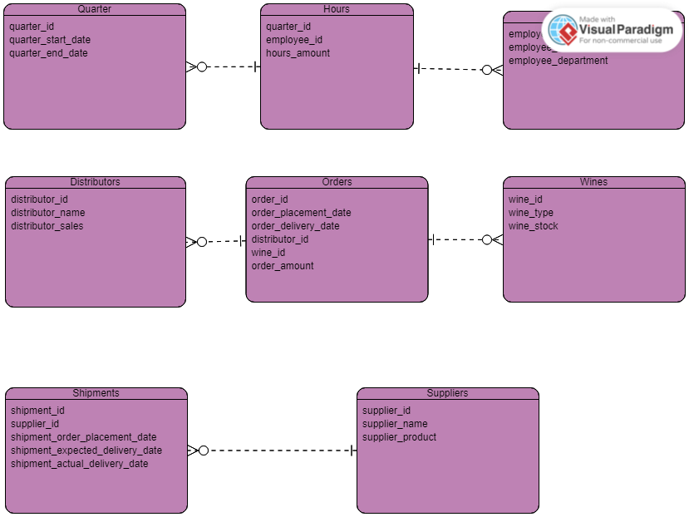

POST-EDIT

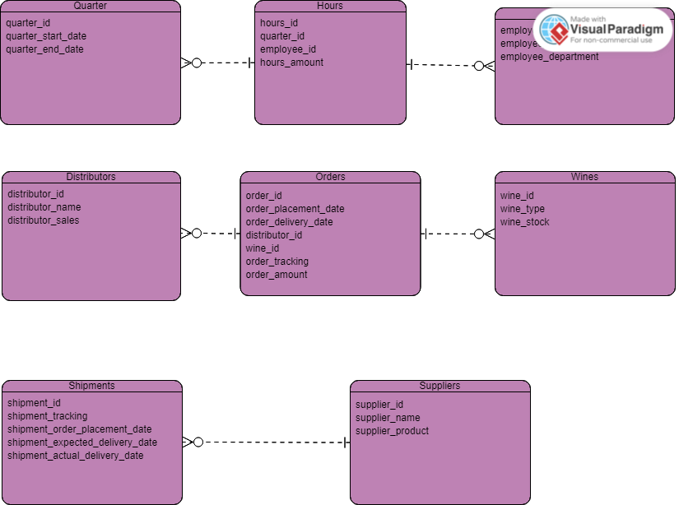

PYTHON OUTPUT SCREENSHOT

We ran out of time and are still working on debugging this, we have all the code as seen in the .py but for some reason are not getting any output as shown below:

